ASSIGNMEN 3: COMPUTATIONAL COMPLEXITY.

JOSÉ LUIS CUMBRERA SÁNCHEZ
1.INTRODUCTION.
We are going to use Petersen’s graph. This is one of the comonest graphs used in graph theory. Here we have it:
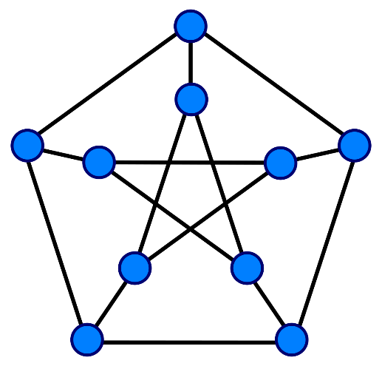1. Petersen’s graph.
We are going to analyze the graph coloring it and searching the posible combinations with k-colors.

2.METHODOLOGY.
I´m using a software called CodeBlock++ to compile my c++ code. The photos have been done in Paint.
I have implemented the graph with a class called graph that includes a list of the colors and a vector of the list of all the adyacents vertex to each one.
I don´t use a genetic function to see if is posible draw the graph or not, i see it in the .cnf file and my functions to draw only uses one of that accepted combination.
C++ functions in the program:
-int main(): It only call the function myjob().
-void myjob(): It´s our main function, it only call the function used to calculate all.
-void inicializargrafo(): Inicialize the graph. I have implemented the graph with a class called graph that includes a list of the colors and a vector of the list of all the adyacents vertex to each one.
-void colorear4C(): It´s a function to draw the graph shown in the image 2.
-void colorear3C1F(): It´s a function to draw the graph shown in the image 3.
-void colorear3C2F(): It´s a function to draw the graph shown in the image 34
- bool sePuede(Grafo::vertice v, int i): Return True if the vertex can be drawn with the color i, seeing the adyacent list or False if it can´t.
-void crearCNF3C(): Creates the .cnf for a 3-col petersen´s graph.
-void crearCNF2C(): Creates the .cnf for a 2-col petersen´s graph.

For .cnf files, you have to use the command (in linux):
-picosat “filename.cnf” the output will be if the clausures are posible and an example.
-picosat “filename.cnf” –all the outout will be all the posible outputs and the total number of them.

3.RESULT AND DISCUSSIONS.
3.1.Coloring it with 4 colors.
Is easy said that is posible, so we haven´t proved it formaly, but here we have a draw o fan example:
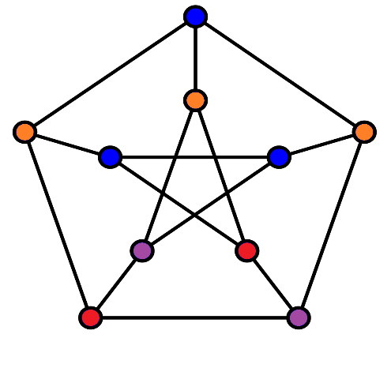2. 4-Colored graph.
3.2.Coloring it with 3 colors.
This is more difficult. I have make a reduction, exactly a Karp reduction, because we haven´t done a general reduction Project. I have implemented only the reduction to this chase WITH THIS GRAPH to dimacs format.
Dimacs format is a format based in rules (True or False), and we can see easily that is posible reeduce 2-col to dimacs format (sat).
I am going to explain ther reduction:
We have 3 types of rules:
- Adyacent nodes have to have other color.
Type1=Edges*nColors.
- A node have to be colored.
Type2=nNodes.
- A node only have
Type3= Type2*3.
Type1+Type2+Type3=Total rules in our output file.
I am going to draw the graph in red, orange and blue, so for each vertex i have 3 variables:
-0_red. -0_orange. -0_blue.
They are boolean variables, so the only can be true or false.
Type1 = ¬(0_red ^ 1_red).
Type2 = (0_red v 0_orange v 0_blue).
Type3= ¬(0_red v 0_orange) ^ ¬(0_red v 0_blue) ^ ¬(0_orange v 0_blue). Each one is one rule!
Applying all the rules, I have 85 in total in this chase.
In the start if we start the line with a c, we can make a comment.
c Hi, this is a comment!
Later, we have tu put this key scombination: p FORMAT VARIABLES CLAUSES
-FORMAT-> Always cnf.
-VARIABLES-> Number of variables.
-CLAUSES-> Is the number of clauses of the problem.
In dimacs format, each variable is a number numerated 1-n. We represent the ¬ as a -. In the end we put a 0.
Type1= -1 -4 0
Type2= 1 2 3 0
Type3= -1 -2 0
-1 -3 0
-2 -3 0
Now, in the command line, if you use the instruction: picosat “filename.cnf” the output will be if the clausures are posible and an example. If you use: picosat “filename.cnf” –all the outout Will be all the posible outputs and the total number of them.
In the file generated by our program, with the command –all, we can see that there are 246 possibles solutions. I have selected 2 of them and here we have the resulting graphs:
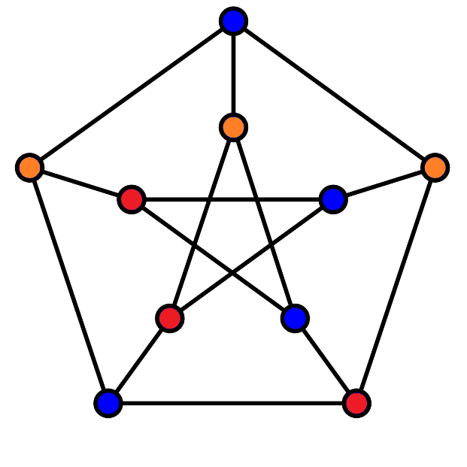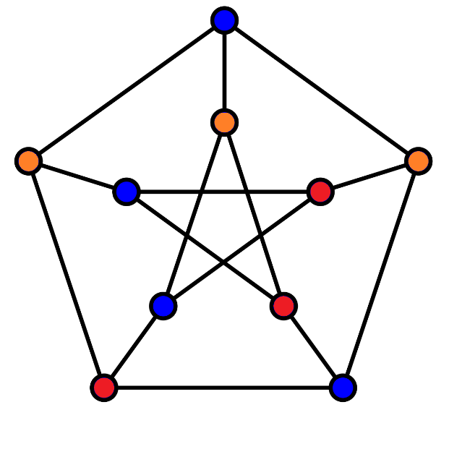
3. 3-Colored graph A. 4. 3-Colored graph B.

3.2.Coloring it with 2 colors.
I have make a reduction, exactly a Karp reduction too. If we use the command picosat, the output is unsatisfiable (0 solutions), so is imposible draw the graph with only two colors. It´s easy see it to with this example:
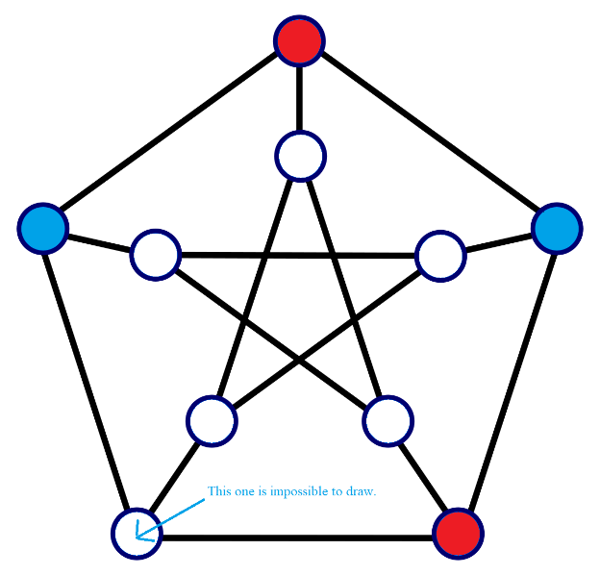5. 2-Colored graph.
3.3.Chromatic number.
Beacuse we can´t draw the graph with 2 colors, the chormatic color is 3.

3.4.Clique number.
I clique is a subgraph whose nodes are conected, the clique number is the maximun subgraph conected between them.
There are a strong relation between the chromatical number and clique number. If we have a gaph with chromatic number of three it mean that the graph isn´t 3-connected. So, the clique number is chromatic number-1, here 2. Here we have a draw to proof it:
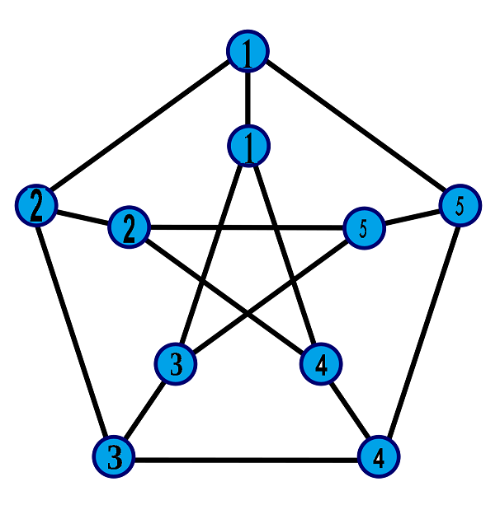6. Clique number.
There are more possible combinations, but all of size 2.

4.CONCLUSSIONS.
We have learnt that we can reduce k-col problem to sat and chromatic number to clique number (we haven´t done it but now we know that it is possible).
We have apply that a problem npc can be ruductible to another npc.
That practice can by interesting for mathematic and for computation, because why apply informatical and computational concepts an also mathematical concepts.

